Kol Simcha Torah Gazette
For parshas tzav 5786
Vol 10 Issue 25 (Whole #490) 10 Nissan 5786/ March 28, 2026
Printed L’illuy nishmas Nechama bas R’ Noach, a”h
For a free subscription, please forward your request to keren18@juno.com
Past emails can be found on the website ShabbosStories.com under Brooklyn Torah Gazette
To Say or Not to
Say the Blessing
By Rabbi Yehoshua Alt
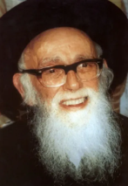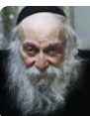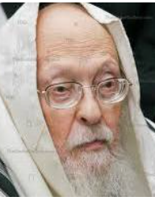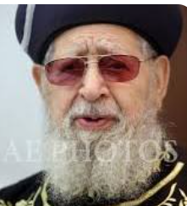
From left to right: Rav Shlomo Zalman Auerbach, Rav Nissim Karelitz, Rav Yosef Shalom Eliyashiv and Rav Ovadia Yosef of blessed memories.

R' Shlomo Zalman Auerbach [Halichos Shlomo, Seder Leil Pesach, p. 225] says that one does not recite a bracha if he consumes that which the doctors forbade him to since it will cause him harm. This is because his act of consumption violates the Torah’s command to maintain one’s physical wellbeing.
R’ Nissim Karelitz [Chut Shani, Brachos, p. 184] ruled that one who is not allowed to eat something for health reasons (such as sugar) and eats it anyway still says a bracha, since ultimately he is deriving pleasure from that food when he eats it. However, if it irritates him when he eats it, then he should not say a bracha.
R’ Yosef Shalom Eliyashiv [Chashukai Chemed, Brachos, p. 225. Ashrei Ha’ish 1 36:15] said that even if one ate something he is not allowed to eat for health reasons, he should still say the bracha before eating it (bracha rishona), but he might be exempt from reciting the bracha after eating it, since one says a bracha rishona even on a crumb and such a small amount presumably does not undermine his health. In spite of this, R’ Eliyashiv [Shiurai Maran Hagaon R’ Yosef Shalom Elyashiv, Brachos, p. 378] ruled that even in such a case, one should still say a bracha achrona since eating just a kzayis wouldn’t endanger him (and the obligation to recite a bracha achronal already comes from eating just the first kzayis).
What should a person do if he recited a bracha over food in the morning and then realized that he had not yet davened shacharis (and therefore he is forbidden to eat due to the prohibition against eating before shacharis)? R' Ovadia Yosef writes that he should taste the food so that his bracha will not have been recited in vain.[Yabia Omer, volume 10, Orach Chaim 6.]
What should a person do if he recited a bracha over milk or dairy food within six hours of eating meat? Many poskim rule that he should take a sip of the milk or a bite of the food so that his bracha will not have been recited in vain. The rationale for this ruling is that the prohibition against consuming milk within six hours of eating meat is less severe than the prohibition of reciting a bracha in vain. All questions of Halachah should be adressed to your local orthodox Rabbi (Excerpted Rabbi from Yehoshua Alt yalt3285@gmail.com.)

Reprinted from the Parshas Tzav 5786 email of Yedidye Hirtenfeld’s whY I Matter parsha sheet for the Young Israel of Midwood in Brooklyn.

The Past and the Future

Tzav / Command (6:2) This word is deliberately expressed in a form that can refer to both the past and the future. In other words, Hashem's commandments are as applicable today as they were when first promulgated.
The rules governing man's behavior and man's devotion to G-d are timeless. Consequently, our observance of the Torah should not be marked by tired, listless
efforts. When we pray, we should not mumble through the prayers out of habit.
Rather, we should remember Whom we are addressing, and say each word carefully. The same applies to observance of Shabbos, our Torah learning and other mitzvos. They should not be routine, but rather should be moments of inspiration.
We must view the Torah and our prayers as instructions from Hashem on how to act practically. If we do not realize this, and do not actually practice what we say and learn, our words and learning have no meaning or purpose. (Lil'Mode U'Lilamed)

Reprinted from the Parshas Tzav 5786 email of Yedidye Hirtenfeld’s whY I Matter parsha sheet for the Young Israel of Midwood in Brooklyn.

Combining the Finite Human Contribution with the G-dly Flame
From the Teachings of the Lubavitcher Rebbe
Rabbi Menachem Mendel Schneerson, Zt”l
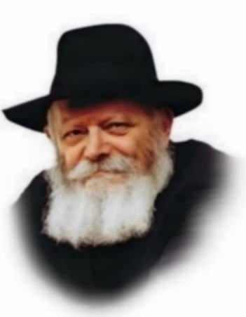
In this week's Torah portion, Tzav, we read about the eight-day consecration of the Sanctuary. All the instructions for building the Sanctuary had been followed. The utensils and altar were ready for use, and the Jews began to bring the various types of sacrifices. Yet, "the Divine Presence did not rest on the work of their hands." For the first seven days, the Sanctuary was erected. But each day it was taken down again. Only on the eighth day of the consecration, when the last trace of spiritual impurity caused by the sin of the Golden Calf was removed, did the Heavenly fire descend and the G-dly Presence rest on the Sanctuary.
We see here two components to the perpetual fire which burned on the altar. On the one hand, a fire came down from Heaven to consume the offerings. But the priests were nonetheless commanded to bring ordinary fire, too. The act of bringing the fire served as a preparation for the G-dly flame which came from Above. Only after human initiative had been taken could the G-dly fire descend. And only at that point did the Sanctuary attain permanence.
Why could the G-dly fire be drawn down only after the human component of the worship was perfected? What special nature of the G-dly fire brought permanence to the Sanctuary?
Human beings are finite. No matter how high their aspirations, they can reach only a finite level of spirituality. And, being finite, human beings cannot reach a level of permanence in their worship without the assistance of G-d, Who is infinite and unlimited. Permanence cannot be attained solely through human effort. The G-dly intervention added a permanence that could not be achieved by human endeavor. The Sanctuary no longer needed to be disassembled.
The fire teaches us that we, as finite beings, must first complete our own tasks and achieve as much as our limited capabilities allow, in order for G-d to provide the spiritual edge which we cannot reach alone.
The completion of the first seven days of the consecration also symbolized the limitations of the physical world. A week constitutes a recognized, full cycle symbolizing the spiritual limitations inherent in the corporeal world. The eighth day of the consecration symbolizes the infinite attribute of G-d which cannot be contained in the natural order of seven. This is the level of "perpetual fire'" which burned on the altar, showing that finite beings could transcend even time itself, through the perfection of their worship of G-d.
The verse concerning the perpetual fire reads: "A perpetual fire shall burn on the altar - it shall not go out." This means that our enthusiasm and warmth towards Judaism must remain kindled and never be allowed to diminish. It is not enough to rely on our spiritual achievements of the day before, or even a minute ago. We must be ever vigilant to ensure that the innate spark of love of G-d in every Jewish soul never grows cold.
Every single Jew is a sanctuary to G-d, as it states, "And they shall build me a Sanctuary and I will dwell in their midst" - in the midst of each and every Jew. If we always keep the spark of love for G-d and Judaism glowing, we can ensure that the Divine Presence finds a dwelling place in this world below.

Reprinted from the Parashat of Tzav 5763/2003 edition of L’Chaim, a publication of the Lubavitch Youth Organization. Adapted from the teachings of the Lubavitcher Rebbe, zt”l.

Rav Avigdor Miller on
Are We to Blame for Why
Gentiles Dislike Jews

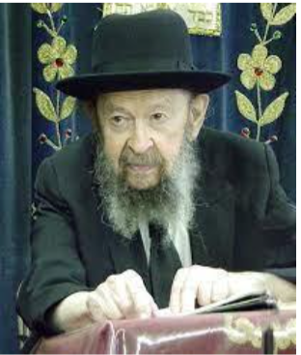

QUESTION: I was approached on the street by a gentile, a neighbor, and he said that the reason why the gentiles dislike Jews is because we keep our laws and we remain separate — we wear different clothing and things like that. What should I answer him?

ANSWER: Answer him, “Do you hate the Amish?”
Have you ever seen the Amish? They look like Satmerers. They have big beards and black hats. Their women wear long dresses, and their hair is tied up with kerchiefs. Who hates the Amish? Nobody.
And so, the answer is it’s not true. It’s only an excuse. The hatred against Jews comes from an entirely different cause, not because they’re different. Actually, it’s the opposite. When the Jews are different, Hakadosh Baruch Hu sees to it that the hatred is minimal. Of course, there’s always going to be, to some extent, animosity against the Jews because if not, the Jew might mingle with his environment and get lost. It’s always going to be there as a wall until Moshiach comes. But if we look and act differently, it’s kept to a minimum. Because then it doesn’t always require such a big wall — it can be kept on a low flame.
The hatred increases in proportion to the way the Jew begins to resemble the gentile. That’s why in Germany — I’m talking about before the Holocaust — it became virulent. In Germany, the Jews did their best to resemble gentiles. The German Jew spoke perfect German. He acted like a German gentleman. He mixed with them and their culture. And once in a while, he even intermarried with the Germans. And that’s where the real hatred originated. Because the more the Jew comes close to the gentile, the more Hakadosh Baruch Hu has to erect a fence of hatred to keep him away.
And so, these are only excuses — that we dress differently, that’s why they hate us, that’s only an excuse.
Of course, when the Nazis portrayed Jews in their newspapers, they showed Jews with beards holding a Talmud, but that wasn’t the reason they were hated. If all the Jews in Germany had beards and held a Talmud, there wouldn’t have been any Hitler, that I can guarantee you.

Reprinted from the Parshas Vayikra 5786 edition of Toras Avigdor. (Transcribed from a classic Thursday night hashkafah lecture delivered by Rav Avigdor Miller on September 20, 1979.

Thoughts that Count
For Our Parsha

This is the law of the burnt-offering...which the L-rd commanded Moses on Mount Sinai, on the day that He commanded the Children of Israel to offer their sacrifices (Leviticus 7:37-8)
From these verses, Maimonides concludes that the proper time for bringing sacrifices is during the day. Nonetheless, he continues, it is permissible to burn any portions of the animal that were not consumed during the daytime throughout the night. Similarly, the Jew's mission in life is to "sacrifice" his animal soul - his desire for physical pleasures - and transform it into holiness. Optimally, this type of service is to be done "in the daytime," when the Jew's connection to G-d is fully revealed. Nonetheless, if our sins have caused us to enter a state of spiritual "night," our service of G-d must continue, for this in itself will dispel the darkness and transform it into light. (The Lubavitcher Rebbe, Bechukotai, 5749)

And the priest shall put on his linen garment (Lev. 6:3)
Rashi comments, "His garment (mado) should befit his stature (midato)." The service of the high priest who performs his duties while wearing the garment of an ordinary priest is invalid. A person must always behave in a manner befitting his stature. The higher up one is, the more is required of him. (Yalkut Eliezer)

And he shall lift up the ashes left from the burnt-offering which the fire consumed on the altar (Lev. 6:3)
A person wishing to witness a fiery, all-consuming service of G-d need not search among the elite; let him better look among the simple Jews who serve G-d with all their heart, for there he will find a true, holy fire. (The Magid of Mezerich)

A fire shall continully be kept burning upon the altar; it shall not go out. (Lev. 6:6)
A person who studies Torah with a friend awakens an eternal G-dly fire. "It shall not go out" - this merit will stay with him forever. (Hayom Yom)

Reprinted from the Parashat of Vayakhel 5763/2003 edition of L’Chaim

The Limerick Boycott of Jews
By Dr. Yvette Alt Miller

A century ago, Limerick's Jews were boycotted, attacked, and driven out of the city. The Jew-hatred that fueled still exists in Ireland today.

Every St. Patrick's Day, the world celebrates Ireland, the green hills, the craic, the warmth of its people. But behind the shamrocks and Guinness, Ireland has a history most revelers never hear about. In the Irish city of Limerick, over a century ago, the town's tiny Jewish community was targeted with economic boycott and physical violence until they were driven out entirely. And the same hatred that fueled that campaign appears to be alive and well in Ireland today.
Limerick is perhaps best-known today for the short, silly rhymes that share its name. Historians speculate that limericks, five-line poems with an AABBA rhyme scheme, originated in pubs in and around the city in the 1890s. But while pub-goers were composing silly verses, Limerick harbored a dark, violent hatred toward its tiny Jewish minority.
Building new lives in Limerick
Jews began arriving in Limerick in the 1880s, fleeing waves of violent pogroms, state-sponsored anti-Jewish riots, that swept the Russian Empire. Locals descended on Jewish towns and neighborhoods, killing Jews with abandon, attacking men, women, and children, and stealing whatever they could.
Hundreds of thousands of Jews fled west, settling across western Europe, Britain, Latin America, and the United States. Improbably, some of these desperate families landed in Limerick. By 1878, 20 Jewish families called the city home. (Other Jewish communities sprang up in Cork, Dublin, Waterford, Belfast, Lurgan, Londonderry, and Dundalk.)

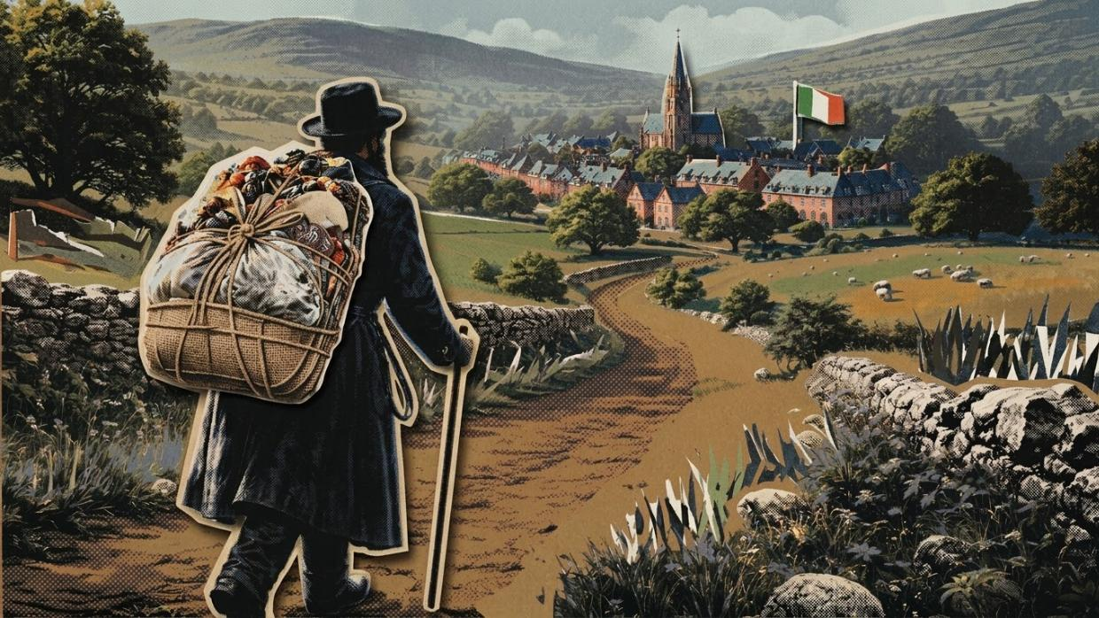

By 1904, 35 Jewish families lived in Limerick, most from present-day Lithuania. Several came from the Lithuanian shtetl of Akmayan, which was 80% Jewish, where Jews faced constant harassment and discrimination from Russian authorities. (In 1915, every Jew in Akmayan was ordered to leave.) These newcomers settled around Colooney Street (today Wolfe Tone Street), established a Jewish cemetery, and began building a community. Two homes served as synagogues. Local Jews formed a mutual aid society to help those in need. Desperately poor, most worked as peddlers, selling clothes, shoes, books, and other goods.
Jewish peddlers proved popular with Irish consumers. Known for extending credit to anyone who asked, they helped people afford goods they couldn't otherwise buy. But resentment built when customers were stuck with the bills. Limerick's residents began viewing their Jewish neighbors with suspicion, and looked for any excuse to turn on them.
Growing anti-Jewish hatred
The first signs came early. On Easter Sunday in 1884, a mob surrounded the home of Lieb Siev and his family, hurling rocks through their windows and injuring Mrs. Siev and her children. The attackers claimed a local maid had seen the family mistreating a chicken. Two ringleaders were tried and sentenced to a month in jail.
Anti-Jewish violence became routine. When a rabbi visited Limerick in August 1892, he noted that just before his arrival two Jewish men had been attacked and beaten outside town. In November 1896, a crowd surrounded the home of Moses Leone and smashed his windows.
Despite this, Jewish life persisted. By 1904, around 130 Jews lived in Limerick. They had a rabbi - Rabbi Elias Levin - and had purchased a plot outside town to build a synagogue. Then the hatred that had long simmered finally boiled over.
Boycott the Jews
On January 7, 1904, two Limerick Jews, Fanny Toohey and Maurice B. Maissell, got married. It was, as the Limerick Chronicle sourly noted, a beautiful event. Fanny wore white satin. Maurice wore a top hat. Bridesmaids arrived in long feather-trimmed capes. Some guests arrived in horse-drawn wagons.

Limerick residents seethed that Jews were getting rich at Christian expense.
The sight of Jews in fine clothes enraged their non-Jewish neighbors. The Limerick Chronicle described the wedding in lavish detail before noting that outside the venue stood "those who wore poverty's motley, while inside were clad in fine broadcloth and silks and satins goodly to look upon." Limerick residents seethed that Jews were getting rich at Christian expense.

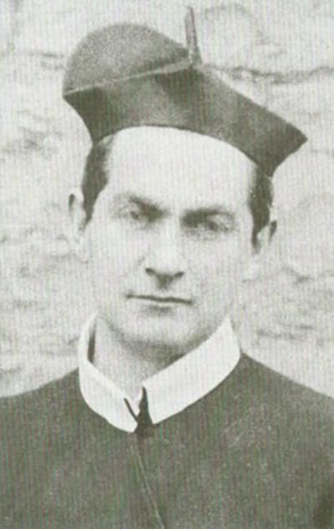
Father John Creagh
Four days later, Father John Creagh, spiritual director of the Arch Confraternity of the Sacred Heart, a Catholic organization with about 6,000 members, addressed the wedding in his Sunday sermon. Calling Limerick's Jews "usurers" (predatory moneylenders), he claimed they had crucified Jesus, "called down the curse on their heads," and were creatures filled with malice. "The Jews came to Limerick apparently the most miserable tribe imaginable," he preached, "and now they have enriched themselves... Their rags have been exchanged for silk. How do the Jews manage to make their money?" His answer: by tricking and manipulating Christians.

About 200 members of the Confraternity immediately took to the streets, throwing rocks and mud at Jews, breaking windows, vandalizing Jewish property. Police arrested eleven. Then Father Creagh urged his followers to boycott Jewish businesses and destroy their livelihoods. A correspondent for the London-based Jewish Chronicle reported hearing mobs chant "death to the Jews" and "we must hunt them out." He wrote that it reminded him of the Kishinev Pogrom the previous year, in which roughly 50 Jews were murdered and thousands more injured in present-day Moldova.
Public figures rushed to support the boycott. Arthur Griffith, the journalist who founded the Sinn Fein political party, was a vocal backer. The Times of London supported the boycott and urged a similar one in England. Many people with open credit accounts at Jewish shops seized the moment to erase their debts. Limerick's Jews found themselves unable to collect on any of their loans.
Some Jewish merchants tried to prove their innocence with facts, as if the boycott were somehow rational and could be defeated with evidence. Max Bland, a Jewish grocer, and Rabbi Levin offered to open all their business records to Limerick's leaders. Rabbi Levin pointed out that of 1,387 citations for breaking the law in Limerick in 1903, just 31 involved Jews, and those were for trivial offenses. None of it mattered. Limerick's leaders, like nearly everyone else in the city, backed the boycott.
Growing violence
In April 1904 alone, there were 40 violent attacks on Limerick's Jews. Saul Goldberg, one of the community's most prominent members, brought a group of Jews to meet Roman Catholic Bishop Edward O'Dwyer to ask for his intervention. The Bishop declined. When Church of Ireland Bishop Thomas Bunbury condemned the attacks, Limerick's mayor and city leaders bristled and doubled down in defending the mobs. The city's Protestants were largely sympathetic to the Jews; its much larger Catholic population was not.
Only one person was ever prosecuted: a young man named Johnny Rahilly, sentenced to a month in jail for throwing rocks at Rabbi Levin. When he was released, a huge crowd greeted him with a gold pocket watch and chain, then carried him on their shoulders through the streets of Limerick.

Leaving Limerick
The boycott lasted over two years, from 1904 to 1906, and achieved its goal. One Limerick Jew, Marcus Joseph Blond, wrote to The Times describing what had happened to him. He had moved to Limerick, worked hard, built a successful store on Henry Street, until Father Creagh's sermons unleashed hatred on the community. Though Marcus had always dealt honestly, his customers boycotted him. He was forced to sell his entire stock and fixtures at humiliating prices to non-Jewish shopkeepers. He left for Dublin after four months and died there in 1905 at the age of 40.
Rabbi Levin fought to keep the community together. He wrote to newspapers in Ireland and England: "If we are to suffer for our religion like our ancestors... let us at least not perish in silence, let our names be inscribed in the bloody civilization and tolerance of Limerick of the twentieth century."
By the time the boycott ended in 1906, Limerick's Jewish community had been gutted. When Ireland gained independence in 1922, just a handful of Jews remained in the city.
Anti-Jewish boycotts today
Limerick still has a small Jewish community, as well as those who call for boycotts of Jews and Jewish institutions. The University of Limerick's Student Life organization has declared it is "committed to participating in the BDS campaign" calling for a total boycott, divestment, and sanctions against the Jewish state, including "boycotting Israeli research institutions and universities."
On May 22, 2024, the university assured anti-Israel activists that it "has no active partnership with Israeli academic institutions." Several Limerick professors have gone further, publicly pledging to boycott Israeli researchers in all forums.
Support for boycotting Israel reaches into Limerick's government as well. City Council member Ursula Gavin has been outspoken in support of Ireland's "Occupied Territories Bill," which would criminalize trade with many Israeli companies in Ireland. Limerick's City Council has flown the PLO flag above its building twice in recent years, in 2024 and 2025. Zoe Lawlor, the leader of Ireland's anti-Israel movement since Hamas' October 2023 terror attacks, lives in Limerick.
Despite having a Jewish population of just 2,200, Ireland has become one of Israel's harshest critics in the European Union. Ireland recognized the State of Palestine in May 2024. Israel shut its embassy in Dublin that same year. A few months later, Ireland joined South Africa's case in the International Criminal Court accusing Israel of genocide and crimes against humanity. In November 2025, Ireland elected Catherine Connolly as President in a landslide. She has described Israel as a "terrorist" and "rogue" state and has called Hamas "part of the fabric of the Palestinian people."
When Ireland opened a community reporting hotline for antisemitic harassment in July 2025, the office was overwhelmed. In just six months, Irish Jews reported 143 incidents, including vandalism, threats, physical assault, hate messages, discrimination, verbal abuse, and exclusion. Nearly a third of the incidents were triggered by visible Jewish identity: speaking Hebrew, wearing a Jewish symbol.
In December 2024, as Irish-Israeli relations deteriorated further, the Limerick Civic Trust weighed in, claiming the 1904-6 boycott was not a "pogrom," as some historians have called it, and insisting it should not color people's views of Limerick, dismissing it as a fringe movement with little public support.
That wasn't true in 1904. And it doesn't appear to be true today.

Reprinted from the current website of aish.com

Six Reasons You Want Authentic,
Handmade Matzah at Your Passover Seder
By Zalman Marshall

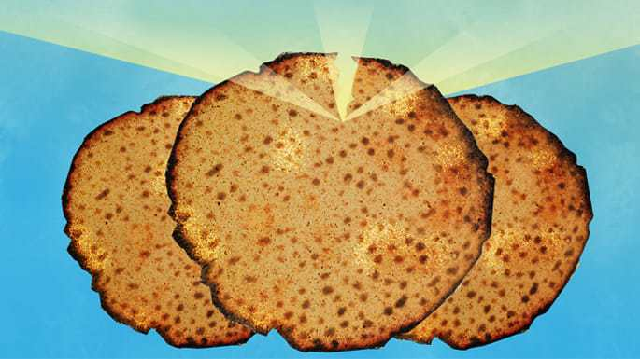
Art by Sefira Lightstone

Eat Your Mitzvah
While there are many mitzvahs you can do nowadays, matzah is the only mitzvah you can eat.
You do other mitzvahs with your hands, your feet, your brain, your heart, your mouth—every part of you. You get inside the mitzvah.
But here, the mitzvah gets inside you. It becomes the blood coursing through your veins and the calories you burn. For seven days, you are literally living off Divine mitzvah-energy.¹
Of course, you want that mitzvah-energy to be of the highest caliber. And that’s only from handmade shmurah matzah. Here’s why:

1. Mind Over Matter
You want your matzah made intentionally for the mitzvah of the Seder. Even with all the progress in AI, we still don’t have a way for machines to do that.
So, we have people, all those involved in the process, say out loud, “We are doing this for the sake of the mitzvah of matzah,” before they begin every new batch of dough. Then the mixers mix, the kneaders knead, the bakers bake—all with that intention in mind.
Your handmade shmurah matzah absorbs that loving intent and pumps it through you once digested.

2. Super Supervision
It’s called shmurah because that means “guarded.” The Torah tells us to guard the matzahs to make sure they don’t come intp contact with anything that might make them rise and become chametz. All Passover matzah is guarded from the time the water and flour mix, but your handmade matzah is guarded from the time of harvest.
That’s a big deal. As some Torah authorities point out, if it’s not guarded from the start, who says it’s guarded?

3. There Were No Machines in Egypt
At the beginning of the Haggadah, we read, “This is the bread of affliction that our forefathers ate in the land of Egypt.” I’ll bet you that bread of affliction didn’t come off a factory line. Sure, baking techniques have changed somewhat—matzahs were once thicker and softer. But the closest we can get to the matzah they ate back then is handmade, brick-oven-baked matzah.

4. The Real Shape
Since the Exodus (and even as far back as Abraham, who also celebrated Passover), and down through the generations, the matzah used for Passover has been referred to as ugot. That means “round cakes.” No, not square. Round.
Yes, we know machines have an easier time with squares. Let the machines leave Egypt and make their own Passover.

5. Eat Your Faith
It has been suggested that the Egyptians, who believed in numerous deities, shaped their bread to have as many sides as the powers they believed in. If they believed in three deities, a triangle; for four, a square, and so on. The Jewish people were therefore careful to keep their matzah round.² In fact, Passover is known as the holiday we celebrate to strengthen our faith in G-d Almighty.
With all this in mind, we can better appreciate the Zohar, which calls the Seder matzah “bread of faith” and “bread of healing.”³

6. It Tastes Better
After all, it's handmade. And brick-oven-baked.
Today, you can get the real deal at your local kosher supermarket, imported from bakeries across the globe. There’s whole wheat, spelt, and even gluten-free oat matzah. As well, each bakery’s matzah tastes slightly different.
Try a variety and choose your favorite. Tell us the results in the comment box below.
One more important thing: At both Seders, you need to consume at least a quarter of a round matzah (or half a machine matzah) within a few minutes. And it must be after nightfall. After that, enjoy as much as you want the rest of Passover as well).
May the matzah and holiday of Passover help us journey from our own self-imposed limitations and spiritual slavery to true freedom in both spirit and body. Wishing you a joyous, meaningful, and kosher Passover!

Reprinted from the current website of Chabad.Org

******************************************************************
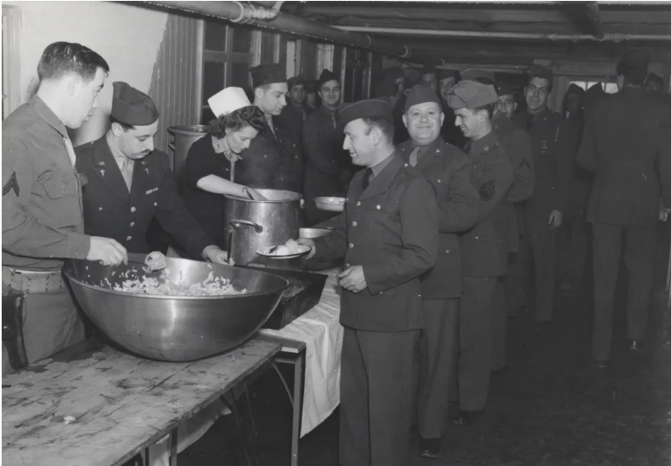
Hebrew religious services, celebrating the Passover, held at Alafoss Hospital in Iceland. 2nd Service Group. April 20, 1943.

